# Analysis – use cases summary

This is mostly a work document for the post-elicitation stage done with all analysts after the initial interviews and document reviews. Do this first. It’s a summary of the use cases in bullets or numbers serving like a table of contents. This is an optional part of a project document but when there are many use cases, it is very helpful.

## Actors

First step in analysis is to brainstorm and validate these roles and/or systems.

* client
* bank
* ATM

## Use case names

Second step in analysis is to brainstorm and validate scope at the goal level.

### System use cases

Only those use cases which start after the software is running and an actor directly interacts with the system.

* withdraw cash - client
* deposit funds- client
* transfer funds- client
* request balance- client
* go to idle screen - ATM

### Business use cases

Any use case that does not completely exist as an interaction between software and the actor.

* update software - bank
* remove deposits- ATM
* replace machine - ATM
* replenishes cash drawer- ATM
* fix machine - ATM

### Use case diagram

Here would be a good place to put a diagram(s) showing the relationships of all the use cases. A good online tool is <https://yuml.me/diagram/usecase/draw>

System use cases

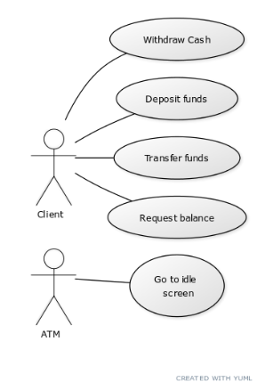

Business use cases

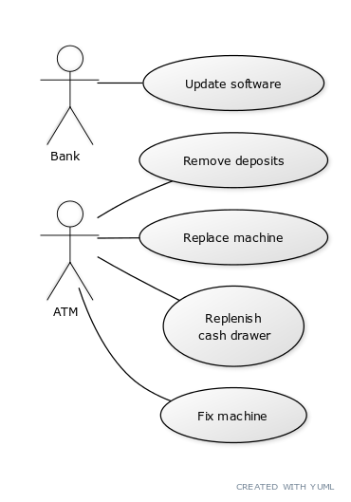

## Grouped use cases

Use cases can be structured to roll up to a group name but are useful when complexity is high. Place bigger use cases that don’t all have the same flow of events here but have a common theme.

Grouped use cases are either system or business use cases and can be groups of goal level use cases or groups of partial use cases. Also common in this section are the Manage <Entity> type of use case which expands into the CRUD use cases. e.g. Manage Account = Create Account, Read Account (Display details of account), Update Account, Delete Account.

* Do transaction
  + Withdraw cash
  + Transfer
  + Request
  + Deposit
* Manage something
  + Create
  + Read
  + Update/Edit
  + Delete

## Partial goal names found

Use cases can be structured to drill down to a sequence of tasks not ending in a goal with value or repeatable. That sequence may be assigned a name to help out understanding e.g. Log In or Search for Product. These are helpful to identify reusable parts and cut down the amount of repeated text in a set of use cases, but not necessary.

* Start session
* End session